Computer Language Coding Concepts

Clauses in Clauses in a Diagram
Clauses in clauses have been conceptually explained in the article Clauses in Clauses.

This article only illustrates how clauses in clauses look in a diagram.

Because clauses are always part of a parent command, the parent command is displayed in the pictures below as the outer square. Inside the square is a clause, and inside that symbol are two clauses in a clause. Inactive clauses are squares. Active clauses are diamonds.

Inactive clauses in an inactive clause in a command definition:

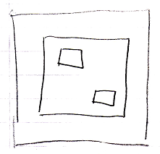

Active clauses in an inactive clause in a command definition:

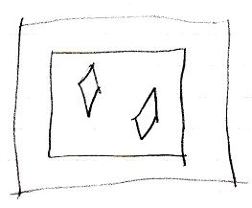

Inactive clauses in an active clause in a command definition:

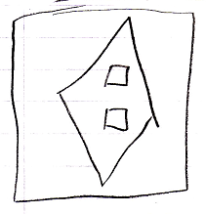

Active clauses in an active clause in a command definition:

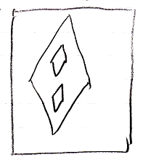

The creation behavior of clauses in clauses will not be further explained with diagrams in this article. Refer to the article Creation Behavior of Command Callls in a Diagram for an illustration of how the creation behavior of command calls looks in a diagram.

See also: Clauses in Clauses,
Creation Behavior of Command Calls in a Diagram

Author & Copyright: Jan-Joost van Zon Date: August 9, 2008 – August 9, 2008 Location: Oosterhout, The Netherlands Status: Finished

